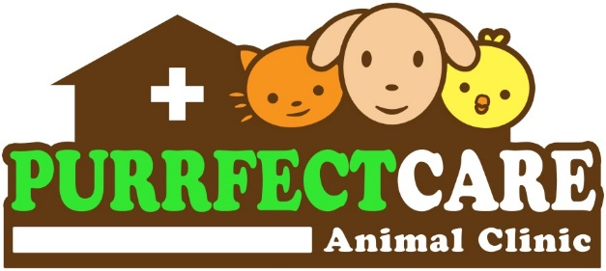
Barrientos Street, Layawan, Oroquieta City
(Near St. Therese Hospital)
Contact no: 0926-740-8552

GROOMING/SKIN TREATMENT AGREEMENT

I hereby AGREE to have my pet ____________________________ (Name of pet) groomed and/or undergo skin treatment at PURRFECT CARE ANIMAL CLINIC, subject to the following conditions:
- That authority is given to any veterinarian(s) or pet groomer(s) to perform the grooming and/or skin treatment deemed necessary for the well-being of my above-mentioned pet.
- That I am aware my pet is fit for grooming; otherwise, I will responsibly seek veterinary consideration before having my pet groomed.
- That the veterinarian(s) or pet groomer(s) will exercise due diligence in the care and handling of my pet.
- That I am aware of the risk of any hospital-acquired infections which my pet may obtain, yet I do not hold PURRFECT CARE ANIMAL CLINIC or any of its staff accountable.
- That sedation may be suggested if the pet is beyond the veterinarian’s and/or groomer’s control, with an additional payment required.
- That any loss of my pet due to fire, theft, or running away is not the liability of PURRFECT CARE ANIMAL CLINIC, provided that proper precautions have been made against these risks.
- That the veterinarian(s) or pet groomer(s) are not liable for any death or complications arising from adverse reactions to drugs, soap, shampoo, other agents used, or other accidents beyond the control of the veterinarian(s) and pet groomer(s) during grooming/treatment.
- That no stipulation whatsoever has been made as to the result of treatment and/or recovery of my pet.
- THAT I AGREE TO PAY ALL MY OBLIGATIONS ON OR BEFORE THE DISCHARGE OF MY PET.
IN WITNESS WHEREOF, HEREBY AFFIX MY NAME AND SIGNATURE THIS _______ DAY OF ___________, 20___ IN LAYAWAN, OROQUIETA CITY, MISAMIS OCCIDENTAL.
_____________________________________
OWNER’S SIGNATURE OVER PRINTED NAME
ADDRESS: ___________________________
CONTACT NO: _______________________

__________________________
WITNESS: RITCHEL A. INTING


Barrientos Street, Layawan, Oroquieta City
(Near St. Therese Hospital)
Contact no: 0926-740-8552

GROOMING/SKIN TREATMENT AGREEMENT

I hereby AGREE to have my pet ____________________________ (Name of pet) groomed and/or undergo skin treatment at PURRFECT CARE ANIMAL CLINIC, subject to the following conditions:
- That authority is given to any veterinarian(s) or pet groomer(s) to perform the grooming and/or skin treatment deemed necessary for the well-being of my above-mentioned pet.
- That I am aware my pet is fit for grooming; otherwise, I will responsibly seek veterinary consideration before having my pet groomed.
- That the veterinarian(s) or pet groomer(s) will exercise due diligence in the care and handling of my pet.
- That I am aware of the risk of any hospital-acquired infections which my pet may obtain, yet I do not hold PURRFECT CARE ANIMAL CLINIC or any of its staff accountable.
- That sedation may be suggested if the pet is beyond the veterinarian’s and/or groomer’s control, with an additional payment required.
- That any loss of my pet due to fire, theft, or running away is not the liability of PURRFECT CARE ANIMAL CLINIC, provided that proper precautions have been made against these risks.
- That the veterinarian(s) or pet groomer(s) are not liable for any death or complications arising from adverse reactions to drugs, soap, shampoo, other agents used, or other accidents beyond the control of the veterinarian(s) and pet groomer(s) during grooming/treatment.
- That no stipulation whatsoever has been made as to the result of treatment and/or recovery of my pet.
- THAT I AGREE TO PAY ALL MY OBLIGATIONS ON OR BEFORE THE DISCHARGE OF MY PET.
IN WITNESS WHEREOF, HEREBY AFFIX MY NAME AND SIGNATURE THIS _______ DAY OF ___________, 20___ IN LAYAWAN, OROQUIETA CITY, MISAMIS OCCIDENTAL.
_____________________________________
OWNER’S SIGNATURE OVER PRINTED NAME
ADDRESS: ___________________________
CONTACT NO: _______________________

__________________________
WITNESS: RITCHEL A. INTING

